TREE DECISION:
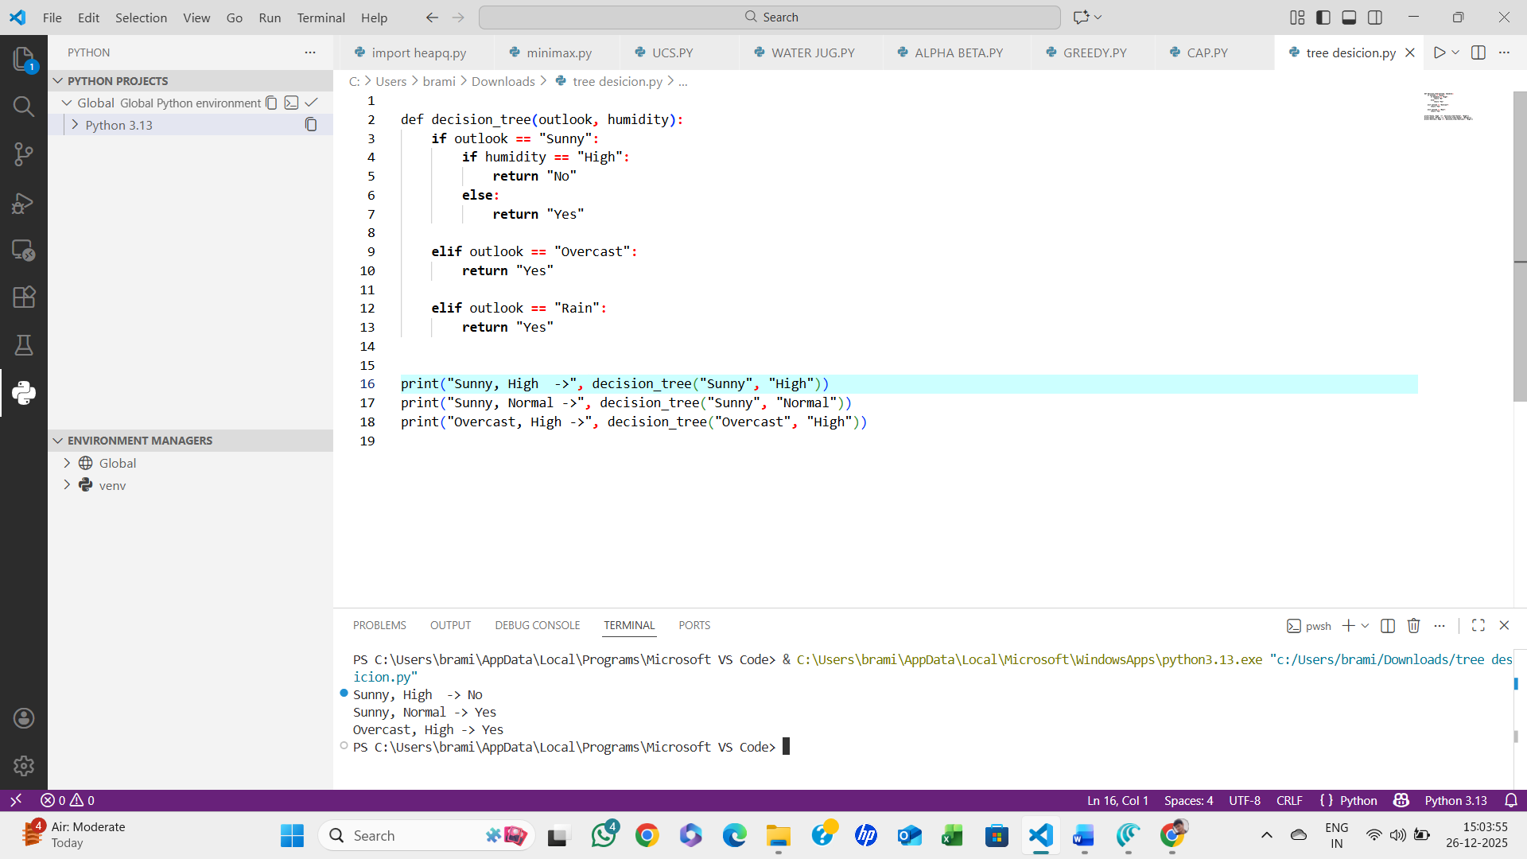

ALGORITHM:
- Start from the root node (Outlook)
- If Outlook = Sunny
  - If Humidity = High → No
  - Else → Yes
- If Outlook = Overcast → Yes
- If Outlook = Rain → Yes
- Return the decision result
- STOP.

